**How to Manage a Security Group on AWS Cloud**

**1.** Go to the AWS Console through the URL http://aws.amazon.com/console . Select the EC2 service.

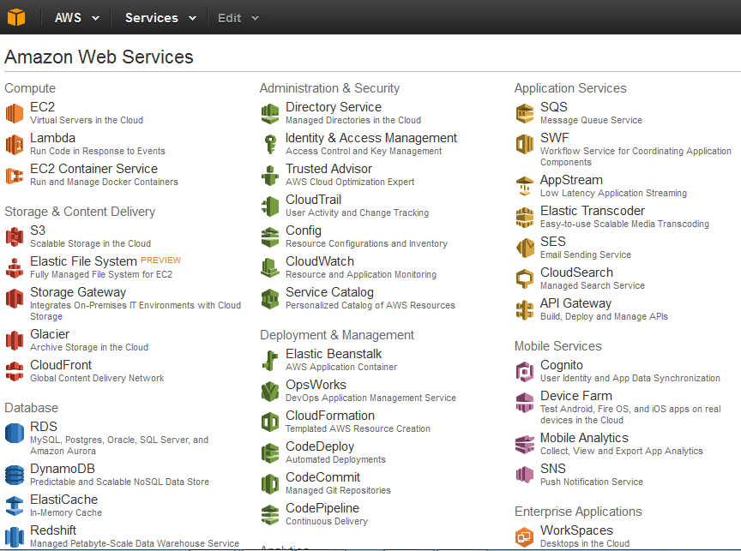

**2.** Select security groups from the EC2 dashboard.

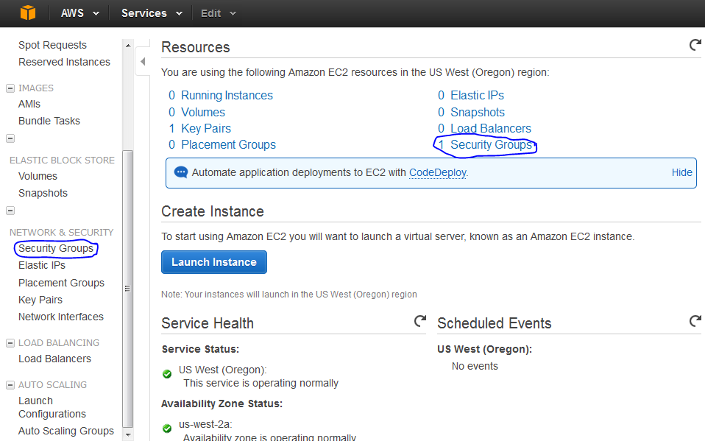

**3.** The Security Group console shows all the existing security groups of that region. Click on the

“Create Security Group” button.

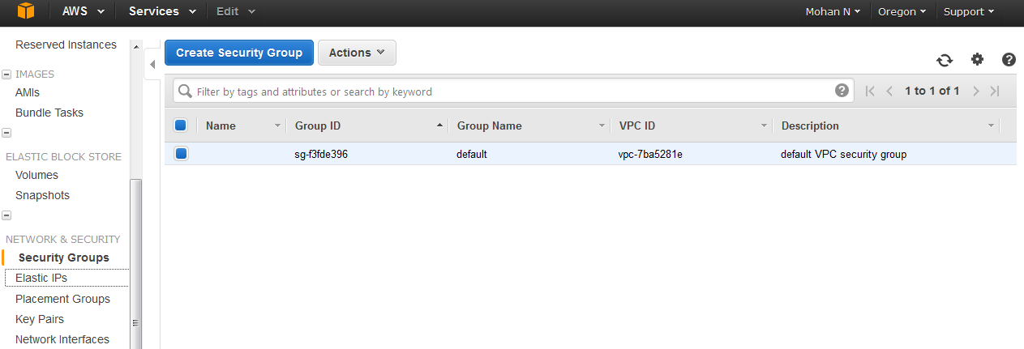

**4.** Provide the name of the security group and the description. If the user is launching the instance in

VPC then select “VPC”, or else select “No VPC”. Click on “Yes, Create”.

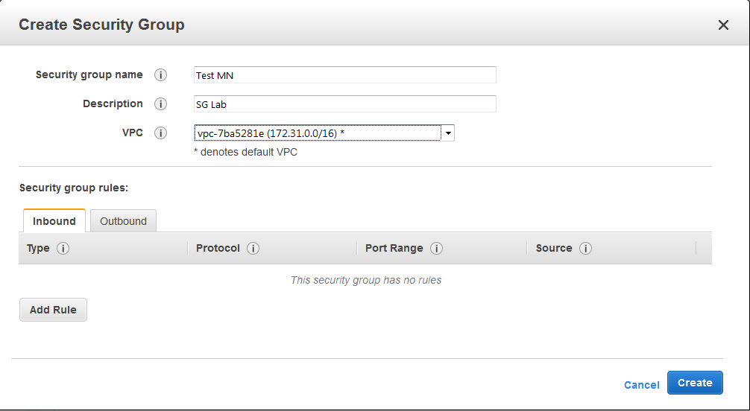

**5.** The security group will be created and available in the Security Group console. To delete a security

group, select the security group, go to actions and click on “Delete Security Group”.

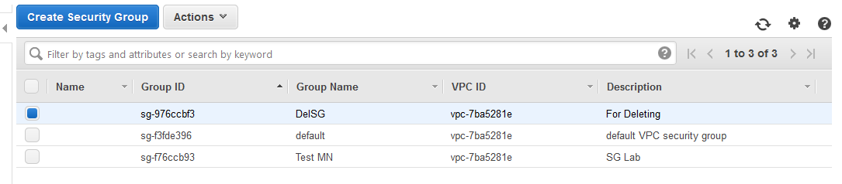

**6.** AWS will ask for a confirmation before deleting the security group. Click on “Yes, Delete”.

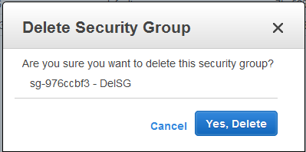

**7.** The group will be deleted immediately and removed from the AWS Security group listing.

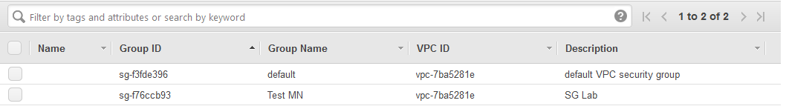

**8.** If a security group is assigned to some instance, AWS will not allow for deleting that security group.

